1. Request Template – Request Category – Service Request or Incident
2. Service Request – If the user needs something new
3. Incident – If the user needs to report something broken
4. Problem
5. Task – Work that needs to be done.
6. Knowledge base

Article

1. Comment

4. Problem

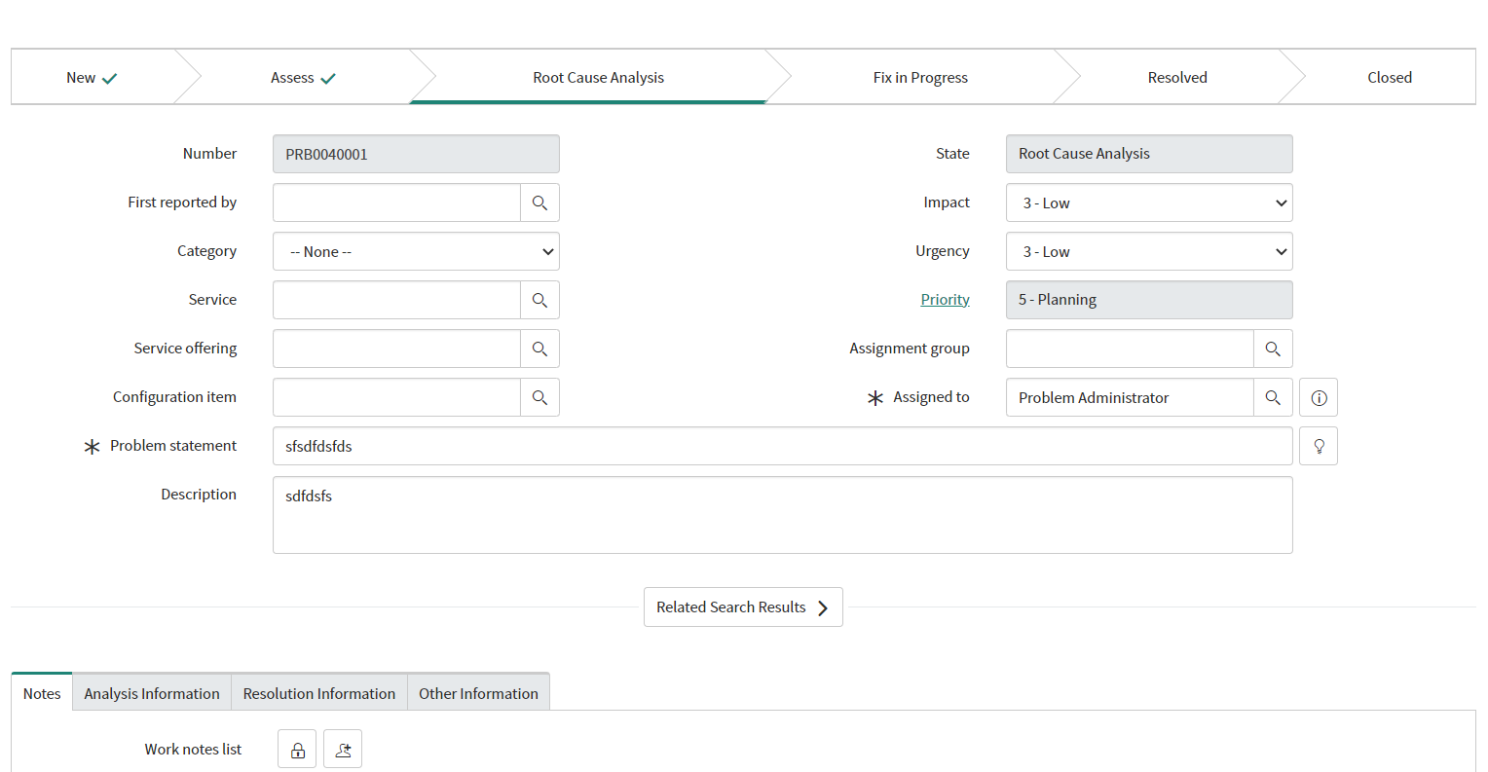

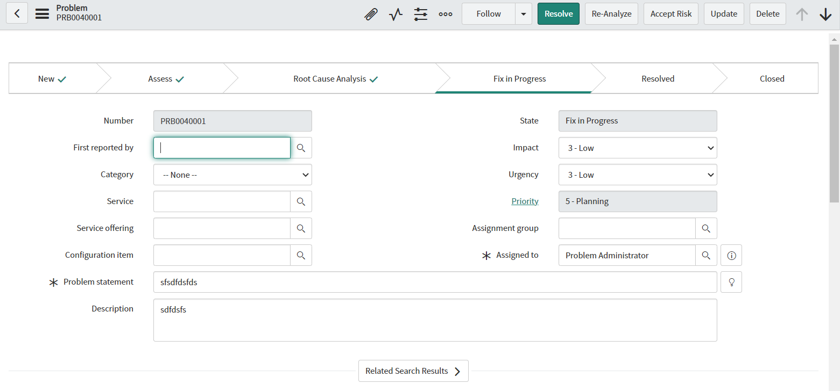

---------------Change Management--------------------------------

1. Change Request
2. Change Order

ECO

MCO

1. Change Implementation
2. Change Validation